Chapter 4, Problem 4.

Use linearity to determine i_{o} in the circuit in Fig. 4.72.

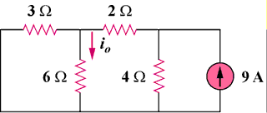

Figure 4.72
For Prob. 4.4.

